Github repo link : https://github.com/Jeevith-gowda/Cloud-computing-hands-on-L3

Conntainer log’s screenshot:

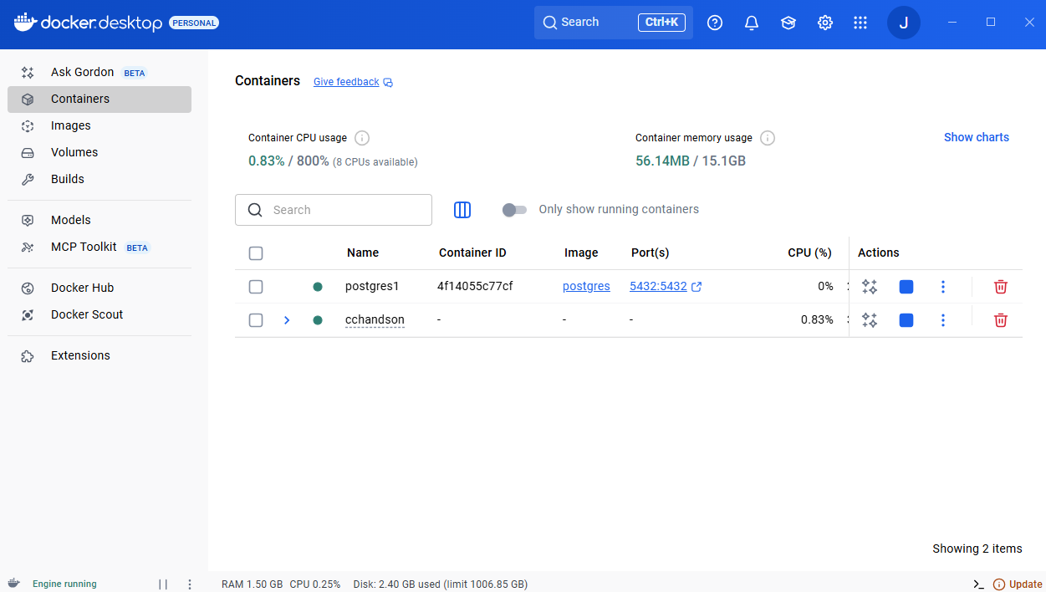

Local host’s screenshot:

